**555 Timer Project**

## Introduction

In this project, we will examine the charge and discharge time of a resistor-capacitor (RC) circuit. We will also learn about a simple integrated circuit (IC), 555 Timer. We will learn how the charge and discharge time of an RC circuit is used in simple designs with the 555 timers to create pulses of different duration.

We will end the project with building a circuit that once triggered turns on an LED for a time duration of our choosing. Time permitted, we will extend the circuit to one that toggles an LED indefinitely.

## Discussion Overview

### Charge/Discharge Time of an RC Circuit

As discussed previously, the charge and discharge time of an RC circuit follow a simple and well defined profile. At time 0, the charge, and therefore the voltage, across the capacitor are 0. The charge and the voltage build up quickly at the beginning, but as the capacitor reaches its maximum charge, the charge build-up slows down.

The time it takes to charge a capacitor is a function of how large the capacitor is (its capacitance) and how large the series resistance is. The chart below displays the charge time of a capacitor as a function of multiples of RC.



You might recall that a capacitor charges to ~63% of the input voltage after a time t63% = 1RC. It charges to ~95% of the input voltage after a time t95% = 3RC. It follows a similar profile when discharging. In other words, a capacitor discharging through a resistor loses ~63% of its charge in a time t63% = 1RC and ~95% if its charge in a time t95% = 3RC.

Electrical engineers use these time constants to design RC circuits that produce very specific time durations. In the next section we learn about one such circuit.

### 555 Timer IC

The 555 timer IC is a highly stable device for accurate time delays or oscillation. Additional inputs are provided for triggering or resetting the device if desired. In the time delay mode of operation, the time is precisely controlled by one external resistor and capacitor. For a stable operation as an oscillator, the free running frequency and duty cycle are accurately controlled with two external resistors and one capacitor.

The block diagram of the device is given below in Figure 1.

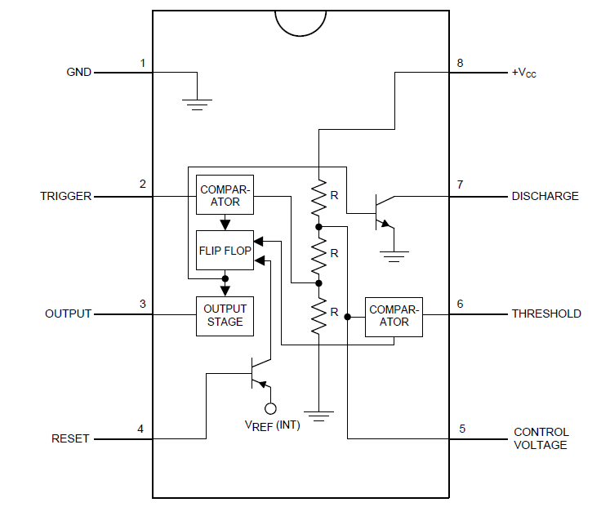

Figure 1 - 555 Timer Block Diagram

#### Operation

The 555 Timer’s two “comparator inputs “Trigger” (pin 2) and “Threshold” (pin 6) control the output (pin 3) of the chip. When the Trigger pin is set to low (less than 1/3Vcc), the output of the chip is set to high (Vcc). Additionally, the transistor connected to the “Discharge” pin (pin 7) is turned on.

If, on the other hand, the voltage input on the Threshold is set to high (greater than 2/3Vcc), the output is set to low (0V) and the Discharge transistor is turned off.

The 555 Timer can be operated in two modes: 1) Mono-stable or one shot and 2) Astable or periodic.

##### Mono-Stable Operation

In this mode of operation, the timer functions as a one-shot (Figure 2). The external capacitor is initially held discharged by a transistor inside the timer. Upon setting the Trigger input (pin 2) to less than 1/3 Vcc to, the flip-flop is set which both releases the short circuit across the capacitor and drives the output high.

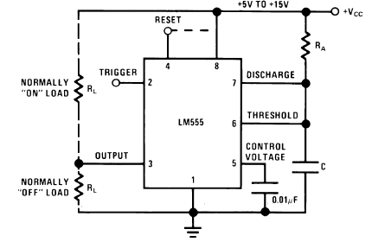

Figure 2 - Mono-stable Operation

The time that it takes the capacitor to charge to the “Threshold” voltage, 2/3Vcc, is given by

$$t=1.1R_{A}C$$

Eq. 1

The comparator then resets the flip-flop which in turn discharges the capacitor and drives the output to its low state.

##### Astable Operation

If the circuit is connected as shown in Figure 3 (pins 2 and 6 connected) it will trigger itself and free run as a multivibrator. In this mode of operation, the capacitor C charges and discharges between 1/3 VCC and 2/3 VCC. The external capacitor, C, charges through RA + RB, and therefore, the charge time is given by

$$t_{1}=0.693\left(R_{A}+R_{B}\right)C$$

Eq. 2

The capacitor discharges, on the other hand, through RB. Therefore, the discharge time is given by

$$t_{2}=0.693R_{B}C$$

Eq. 3

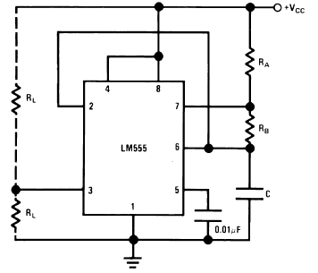

Figure 3 - Astable Operation

Thus, the duty cycle may be precisely set by the ratio of these two resistors.

In the next section, we will go through step by step construction of the mono-stable circuit.

## Circuit Construction

Using a 555 Timer IC, resistors, capacitors and an LED, we will construct a simple timing circuit that will turn on an LED for a duration of our choosing. The following steps will walk us through determining the R and C values and the construction the circuit shown in

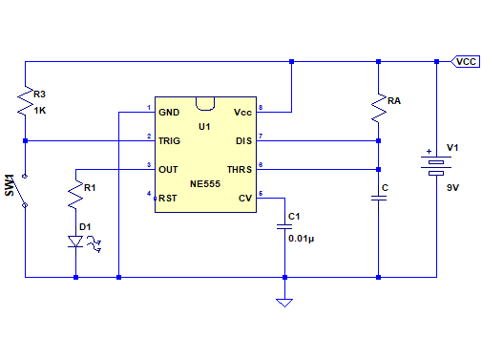

Figure 4 - 555 Timer Circuit

### Connecting the LED

We would like for the LED to turn on when we trigger the 555 Timer chip. Since the output of the chip is high (at Vcc) when triggered, we will connect the LED and its current limiting resistor from the output (pin 3) to ground.

1. Given a turn-on or forward voltage of $V_{f}=2V$ for your LED and a required current of $I_{f}=5ma$ when the LED is on, determine the current limiting resistor for the LED.
   1. Record the forward voltage and current of your LED $$V_{f}=_________________________V \\ I_{f}=_________________________ma$$
   2. The output of the 555 Timer when triggered or will be at Vcc - 2 = 7V. Determine the current limiting resistor using Ohm’s Law $$R_{1}=_____________________Ω$$

### Setting the Pulse Duration

In this portion of the project, we will determine the R & C values for the timer circuit such that the LED is turned on for the time duration of our choosing when the 555 Timer chip is triggered.

1. Pick a time duration between 1 & 5 seconds for which the LED should remain on $$t_{1}=______________________s$$
2. Recall that the time duration for which the output of the 555 Timer chip is high (Vcc) is the same as the time that the capacitor is charged through RA and is given by Eq. 1 $$t=1.1R_{A}C$$
3. Using this equation, we can solve for either RA or C. Let’s solve for RA.
4. Now, let’s pick a convenient value for C $$C=100µF$$
5. Now we can solve for the value of RA

Construct the circuit in Figure 4 with the resistor and capacitor values above and test the circuit.

### Observations

1. Is the circuit behaving as you expected? If not, why?
2. How would you change circuit to have the LED stay on for twice the amount of time?
3. What do you think is the maximum time duration you can make the LED stay on?

## Blinking LED Circuit

As discussed in the “Astable Operation” section, if the trigger input is also time controlled, one can make the circuit toggle (turn on and off) indefinitely. This is accomplished through the circuit shown below.

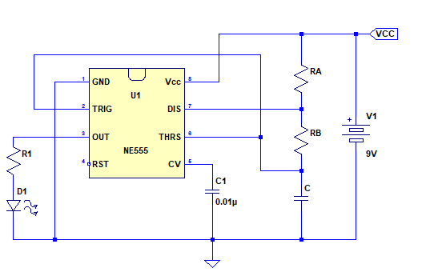

Figure - 555 Blinky Circuit

The operation of this circuit is best explained in steps below:

1. When the circuit is first turned on, the voltage across the capacitor C is at 0. Since the capacitor is also connected to the “TRIG” input, the comparator detects the voltage at the “TRIG” input to be less than 1/3 VCC and enables the output. This causes the LED to turn on. The same comparator also turns off the transistor at the “DIS” pin which in turn allows the capacitor C to start charging through the two resistors $\left(R_{A}+R_{B}\right)$.
2. Once the voltage on the capacitor has reached 2/3 VCC, the comparator at the “THRS” input is activated which disables the output turning off the LED. The same comparator also turns on the transistor at the “DIS” input which will then causes the capacitor C to start discharging through $R_{B}$.
3. Once the capacitor C has discharged sufficiently down to 1/3 VCC, this will again causes the comparator at the “TRIG” input to trigger enabling the output and turning off the transistor at the “DIS” input. Once this transistor is turned off, the capacitor C start charging again returning the operation back to step 1 above.

As can be seen from above steps, the circuit will continue cycling through steps 1, 2 & 3 indefinitely.

The duration for which the output is on is determined by the capacitor C’s charge time through RA + RB as explained in step 1 above. Since the capacitor charges and discharges between 1/3 VCC and 2/3 VCC (or by 2/3 VCC – 1/3 VCC = 1/3 VCC), the charge duration is given by Eq. 2, $t_{1}=0.693\left(R_{A}+R_{B}\right)C$.

The duration for which the output is off is determined by the capacitor C’s discharge time through RB. Again, since the capacitor is discharging by only 1/3 VCC, the duration is given by Eq. 3, $t_{2}=0.693R_{B}C$.

Picking the values of C, RA & RB will allow us, the designer, to control the turn on and turn off time of the LED to any duration of our choosing. We will do this next.

### Designing the Timing Circuit

1. Pick a duration between 0 & 1 second for which the LED should remain off. (Recall that this corresponds capacitor C’s discharge time through $R_{B}$.) $$t_{2}=______________________s$$
2. Solving Eq. 3 for $R_{B}$, we have $$R_{B}=\frac{t_{2}}{0.693C}$$
3. Given our choice of capacitor $C=100µF$, we have $$R_{B}=\frac{t_{2}}{0.693×100×{10}^{-6}}=_____________________Ω$$
4. Now, let’s set the duration for which the LED should remain on to twice the time it is off. $$t_{1}=2t_{2}=______________________s$$
5. Recall that $t_{1}$ is the time that the capacitor charges through $\left(R_{A}+R_{B}\right)$, and its equation is given by Eq. 2. Solving this equation for $R_{A}$, we have $$R_{A}=\frac{t_{1}}{0.693×100×{10}^{-6}}-R_{B}=_____________________Ω$$

Construct the circuit in Figure 5 with the resistor and capacitor values above and test the circuit.

### Observations

1. Can you set the timer to have a shorter turn-on time (output is enabled and the LED is on) than its turn-off time? If yes, how, and if not, why not?
2. What is the frequency of the circuit that you constructed above?